**Gracious Germents**

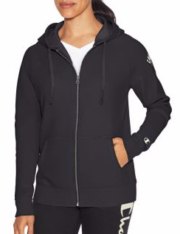

**DESCRIPTION:**

We've re-interpreted our Heritage Zip Hoodie with a modern fit and better-than-ever feel.

Garment washed fleece for superior softness and vintage look.

Brushed interior is super-soft against skin.

Stretch ribbed side insets, cuffs and waistband for a stay true fit.

Raglan sleeves with classic Champion graphics on left arm.

Hood with tipped drawcord.

Sturdy metal zipper.

Split kanga pockets.

C logo at cuff.

Units Per Pack: 1

Country of Origin: Imported

**ADDITIONAL INFORMATION**

Weight: 0.5 kg

Dimensions: 10 × 8 × 3 cm

Size: S, M, L, XL,

Price: $20.00